International Workers’ Conference 2018
Friday March, 23rd – Sunday, March 25th
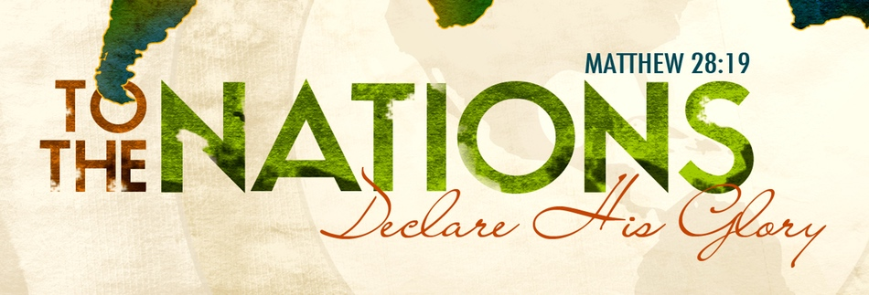
This year's Missions Conference will feature Kent & Beth Copeland, international workers to Cambodia. It is our privilege to again be co-hosting this year’s Missions Conference with Amherst Alliance Church (AAC).
AAC is located at 3915 Millersport Highway, Buffalo NY 14228.
Please see the list of events below for event locations.

International Workers’ Conference Events

- Friday, March 23rd from 6:30-10pm @ NAC- Combined Youth Night for NAC and AAC. Youth leaders for both churches will be present. Pizza, snacks, & drinks will be provided.

- Saturday, March 24th from 8:30-10am @ NAC- Combined Men’s Breakfast for NAC and AAC.

- Saturday, March 24th from 12-2pm @ AAC- Combined Ladies’ Luncheon for NAC and AAC.
AAC is located at 3915 Millersport Highway, Buffalo NY 14228

Sunday, March 25th we will be joining AAC for Morning Worship Service @ AAC to hear Kent speak.
Service starts at 10:30am
Followed by a combined potluck lunch at AAC.
AAC is bringing main dishes & sides
NAC is bringing salads & desserts

