Sunday, June 9th, 2019

Welcome and thank you for joining us today.
As a guest or visitor, we acknowledge your presence as the only offering expected today.
Announcements

Sunday Evening Breakout: We invite you to come out to Sunday Eveing Breakout. Expect to enjoy fun, snacks, informal bible study and discussion on various topics. There are several options available to you: a Women's Bible Study, a Men’s Bible Study, Youth Group for ages 12-18, and Kingdom Kids for ages 3-7. Come and grow in your faith by interacting with the body. Bring your children to do so as well. Tonight

As of May 1st the Roof Repair Loan has been paid off! Praise the Lord! Please shift all building improvement giving over to the Church Improvement Fund (CIF)

Father’s Day Cookout: Please join us following the service under the pavilion for food, fun and fellowship, in honor of the Dad’s in our lives Sunday June 16th

Mowing Schedule: Please be sure to sign up on the schedule in the sanctuary

Stamp Ministry for Missions: There is a basket on the table in the sanctuary please see Connie Messer with any questions on this project.

NGRM: NAC is committed to serve at the mission on the fourth Friday of each month. Our group meets at 5:15pm at 1317 Portage Rd (the old YMCA). If you would like to join our team and help make a difference you can volunteer to serve or make a cash donation. We are also collecting “care kit” donations. Please see Vikki or Val Matuszkiewicz with any questions and continue to pray for this ministry.

Church Membership

The church membership series serves as a prerequisite class for those seeking membership at NAC. Those seeking membership are encouraged to click on the “church membership” link on our website. There you will find the application for membership, supporting documents, and a link to this sermon series.

Serving You

This Sunday, June 9th, 2019
Greeters: Dave & Pat Kline
Ushers: Team C
Nursery: Wendi Walker & Kylee Jones
Kids Connection: Stephanie Toohey & Cheryl Pirinelli

Next Sunday, June 16th, 2019

Greeters: Janet Haynes & Wayne Gardner
Ushers: Team A
Nursery: Anna Dudek & Janice Bush
Kids Connection: Connie Messer & Emily Schultz

June/July Birthdays and Anniversaries
June 8 Chuck Carlson
June 12 Abigail Piazza
June 17 Robin Ailing
June 20 Wendi Walker
June 23 Katelynn Hein
June 25 Mark Patterson
June 30 Dave DiRienzo
July 6 Shelley Wojciechowski
July 10 Jim & Lynn Straus
July 13 Mike Clayton
July 14 Tim & Kristine Pieczonka
July 15 Geoffrey Smith
July 18 Mandy Perl
July 19 Danny Piazza Jr.

Income/Expense Report for May

May Income | $9,452.78
May Expenses | $13,813.88
May Deficit | $4,3610.10

General Fund Balance | $3,646.98
Church Improvement Fund Report for May
April Income | $659.82
April Expenses | $0
April Surplus | $659.82

Church Improvement Balance | -$2,926.13
For Your Assistance
In Touch Cards:
~ Submit a prayer request or request us to contact you
~ Located in the seat pockets
~ Place in the offering plate

Kids Connection (Children’s Church):
~ Held during the sermon
~ Age 4 -5th grade (age 11)
~ Please sign-in your children in the front foyer
~ Located in the attached building, down the stairs

Nursery:
~ Birth-age 3
~ Located in the attached building, up the stairs through the fellowship hall (in the former foyer next to the library)

Sermon Notes with Prize (for Children & Teens):
~ Fill out a note sheet located on the table in front of the sound booth
~ Turn in your sheet to Holly Piazza for a prize

Wireless Hearing Devices Available:
~ Ask at the sound booth for assistance

Easy Tithe (Online Giving):
~ Available at www.niagaraalliance.com

Greetings

Thank you for joining us in worship today. We trust that God has crossed our paths for a reason. We do not believe your visit is by chance. We want to both encourage you and experience the blessing of your continued presence with us.

Jesus established the church to be a community — a family — to support each other and to tell the world about His love. As a church family, we endeavor to love each other without conditions. As humans we're not perfect at it, but nonetheless we seek to be used by the Lord to demonstrate His love to each other and to those around us.

If you are searching for a group of people who will accept you where you are at in your spiritual journey and also be used to help you grow in your relationship with the Lord, "Welcome" for that is our goal. We look forward to getting to know you better. We're glad you're here. Once again, welcome!

Who We Are

We are a church of the Christian and Missionary Alliance (C&MA), or “The Alliance” as we've come to call ourselves. We began as a missionary organization in 1887. Today there are over 2,000 C&MA churches in the US. We support over 800 missionaries who serve in 58 countries. There are also over 400 other missionaries supported by Alliance churches from at least 12 other countries. You can find out more about the Alliance at www.cmalliance.org

Our Vision

Niagara Alliance Church exists to be a Christ-centered community who gathers purposefully, fellowships personally, and worships passionately as Christ Jesus builds His Church through evangelism and discipleship.

We believe in Jesus Christ as our Savior, Sanctifier, Healer and Coming King. This is expressed in the Alliance logo. The cross stands for the salvation made available to us through Jesus' death and resurrection. The cup was a vessel used by the Old Testament priests to wash their feet with before entering the Holy Place of the Temple and signifies the daily cleansing from sins by the power of the Holy Spirit. The pitcher speaks of oil, a symbol of divine life and physical healing that come from Jesus. The crown symbolizes the return of Jesus to the earth as King of kings and Lord of lords. The globe reminds us of our responsibility to take the message of Christ's love to the whole world. We live out this call together.

Contact Info
7041 Witmer Road
North Tonawanda, NY 14120
(716) 731-5689
www.niagaraalliance.com

Lead Pastor- Rev. Daniel Piazza
Office (716) 731-5689
Dan.piazza020@gmail.com

Pastor of Discipleship- Rev. Mark Perkins
Cell 716-940-9150
rev.mark.perkins@gmail.com

Worship Leader- Dave Bishop
Cell (908) 989-0281
notesurfer@gmail.com

Church Office
Cell (716) 217-9262
Office (716) 731-5689
nacofficeniagara@gmail.com
Welcome To 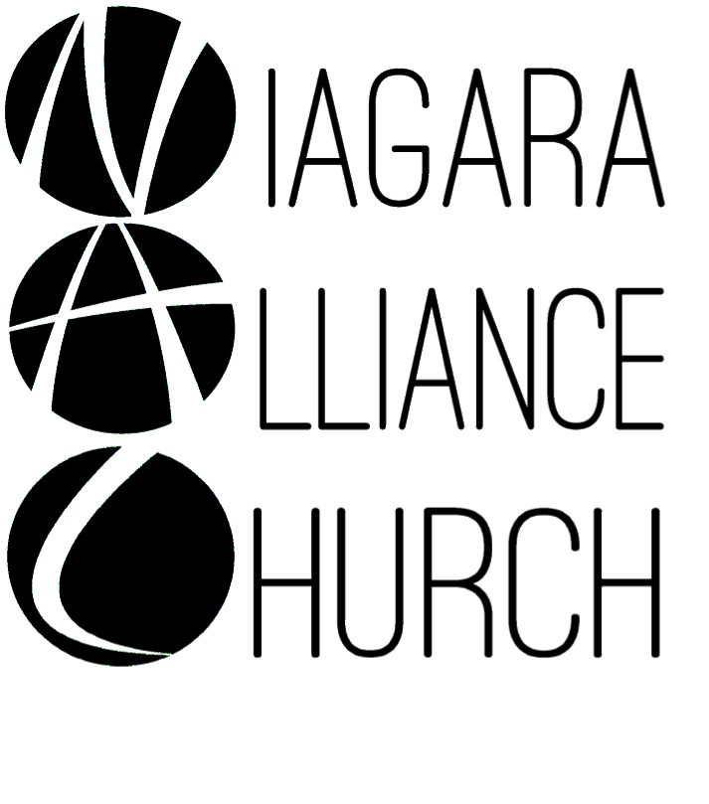
Weekly Worship at NAC:
Sundays:
9:30am LIFE Hour (Sunday School)
~ 9:15am for coffee
~ Classes offered for: adults, teens ages 12-18, middlers ages 8-11, juniors ages 3-7 and nursery services provided for birth-3 years old
~ Located in the library and downstairs fellowship hall
10:30am Worship Service
~ Nursery provided
~ Kids Connection (Children’s Church)- children ages 4-5th grade (age 11) are dismissed before the sermon begins for a biblical lesson and activities in the downstairs fellowship hall with two teachers
6-7:30pm: Breakout - Every Other Sunday Night:
Women’s Bible Study- located in the main foyer, Men’s Bible Study- located in the library,
Youth Group- 7th-12th grades (ages 12-18) - located in the downstairs teen room
Kingdom Kids (2 flexible age groups)- PreK-1st grade & 2nd -6th grades (about ages 3-7 and about ages 8-11) are invited for a hands-on Bible lesson and discussion, playing a game, and snack - located in the downstairs fellowship hall
Wednesdays: Prayer Meeting at 7pm- located in the front foyer and/or sanctuary

