Sunday, March 11th, 2018

Welcome and thank you for joining us today.
As a guest or visitor, we acknowledge your presence as the only offering expected today.
Announcements

Sunday Evening Breakout: We would like to welcome you to join us every other Sunday evening from 6-7:30pm. Expect to enjoy fun, snacks, informal bible study and discussion on various topics. There are several options available to you: a Women's Bible Study led by Janice Bush, a Men’s Bible Study led by Bill Dudek, Youth Group led by Holly Piazza, & Kristine Pieczonka, Kingdom Kids ministry for children led by Stephanie Toohey & Pastor Dan, and Jean Brumfield will lead for ages 3-7. Come and grow in your faith by interacting with the body. Bring your children to do so as well. Tonight!

NGRM: Niagara Gospel Rescue Mission is a ministry devoted to feeding and witnessing to the homeless in Niagara Falls. If you would like to volunteer, please see Val or Vikki Matuszkiewicz. Please continue to pray for this ministry.

Recycle for the Youth Ministry: You can participate in this fundraising opportunity by either dropping off your recycling in the foyer or by going to any of the Bottle Junction locations and dropping it off yourself. If you choose the latter option, just tell them to place it on the account for Niagara Alliance Church. Thanks, in advance for your generosity.
Spring Refresh District Ladies Conference
The Spring Refresh District Ladies Conference is being held on Friday & Saturday, April 27th & 28th at the Auburn Holiday Inn. This is a great time a of fellowship, learning, and hearing from International Workers. The cost of the conference is $75 ($70 for teens) plus the cost to split a hotel room (~$100 divided by how many ladies are in your room). Please sign-up by March 18th. If you have any questions about the Ladies Retreat please see Holly Piazza or Janice Bush.

Internatinal Workers’ Conference
Save the Date: March 23rd, 24th, & 25th
Friday March 23rd: Youth Night at NAC 6:30-10pm
Saturday March 24th: Men’s Breakfast at NAC 8:30-10am & Ladies Lunch at AAC 12-2pm
Sunday March 25th: Sunday Morning Worship Service & potluck lunch at AAC, AAC will bring main dishes & sides & NAC will bring salads & desserts.
We hope to see you at as many of these missions events as you are able to attend!
Please sign up in the Foyer so we can best coordinate with AAC. Thank You!

Serving You

Today

Greeters: Dave & Pat Kline
Ushers: Team C
Nursery: Available
Kids Connection: Holly & Abby Piazza

Next Sunday, March 18th, 2018
Greeters: Deb & Les Spoth
Ushers: Team A
Nursery: Available
Kids Connection: Connie Messer & Cindy LaChat
Church Membership
Pastor Dan will begin a membership series on Sunday, April 22.
This series is designed for both those looking to become members and those who are already members.
March Birthdays and Anniversaries
Mar 2 Nikki DiRienzo
Mar 3 Dave Kline
Mar 3 George & Cindy LaChat
Mar 13 Diana Clayton
Mar 14 Nathaniel Straus
Mar 14 Dave & Nikki DiRienzo
Mar 15 Dave & Alex Bishop
Mar 17 Patty Tompkins
Mar 19 MaryAnn Ricker
Mar 28 Danika DiRienzo
Income/Expense Report for February
February Income | $12,773.01
February Expenses | $9,263.97
February Surplus | $3,509.04

General Fund Balance | $8,022.27
Loan Report for February
Original Loan Amount | $25,850.00
Minimum Payment | $249.61
Additional Payment on Principal | $375.00

Remaining Loan Balance | $11,716.23
For Your Assistance
In Touch Cards:
~ Submit a prayer request or request us to contact you
~ Located in the seat pockets
~ Place in the offering plate

Kids Connection (Children’s Church):
~ Held during the sermon
~ Age 4 -5th grade (age 11)
~ Please sign-in your children in the front foyer
~ Located in the attached building, down the stairs

Nursery:
~ Birth-age 3
~ Located in the attached building, up the stairs through the fellowship hall (in the former foyer next to the library)

Sermon Notes with Prize (for Children & Teens):
~ Fill out a note sheet located on the table in front of the sound booth
~ Turn in your sheet to Holly Piazza for a prize

Wireless Hearing Devices Available:
~ Ask at the sound booth for assistance

Easy Tithe (Online Giving):
~ Available at www.niagaraalliance.com
We would like to encourage Diana Clayton as she continues to progress with her speech therapy due to her recent stroke. Please consider sending her a birthday card or a note to show your love and support! See Janice Bush for her address.
Greetings

Thank you for joining us in worship today. We trust that God has crossed our paths for a reason. We do not believe your visit is by chance. We want to both encourage you and experience the blessing of your continued presence with us.

Jesus established the church to be a community — a family — to support each other and to tell the world about His love. As a church family, we endeavor to love each other without conditions. As humans we're not perfect at it, but nonetheless we seek to be used by the Lord to demonstrate His love to each other and to those around us.

If you are searching for a group of people who will accept you where you are at in your spiritual journey and also be used to help you grow in your relationship with the Lord, "Welcome" for that is our goal. We look forward to getting to know you better. We're glad you're here. Once again, welcome!

Who We Are

We are a church of the Christian and Missionary Alliance (C&MA), or “The Alliance” as we've come to call ourselves. We began as a missionary organization in 1887. Today there are over 2,000 C&MA churches in the US. We support over 800 missionaries who serve in 58 countries. There are also over 400 other missionaries supported by Alliance churches from at least 12 other countries. You can find out more about the Alliance at www.cmalliance.org

Our Vision

Niagara Alliance Church exists to be a Christ-centered community who gathers purposefully, fellowships personally, and worships passionately as Christ Jesus builds His Church through evangelism and discipleship.

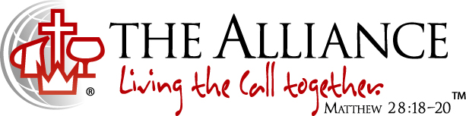
We believe in Jesus Christ as our Savior, Sanctifier, Healer and Coming King. This is expressed in the Alliance logo. The cross stands for the salvation made available to us through Jesus' death and resurrection. The cup was a vessel used by the Old Testament priests to wash their feet with before entering the Holy Place of the Temple and signifies the daily cleansing from sins by the power of the Holy Spirit. The pitcher speaks of oil, a symbol of divine life and physical healing that come from Jesus. The crown symbolizes the return of Jesus to the earth as King of kings and Lord of lords. The globe reminds us of our responsibility to take the message of Christ's love to the whole world. We live out this call together.

Contact Info
7041 Witmer Road
North Tonawanda, NY 14120
(716) 731-5689
www.niagaraalliance.com

Pastor- Rev. Daniel Piazza
Office (716) 731-5689
danielpiazza@tfc.edu

Worship Leader- Dave Bishop
Cell (908) 989-0281
notesurfer@gmail.com

Church Office
Cell (716) 217-9262
Office (716) 731-5689
nacofficeniagara@gmail.com

Welcome To 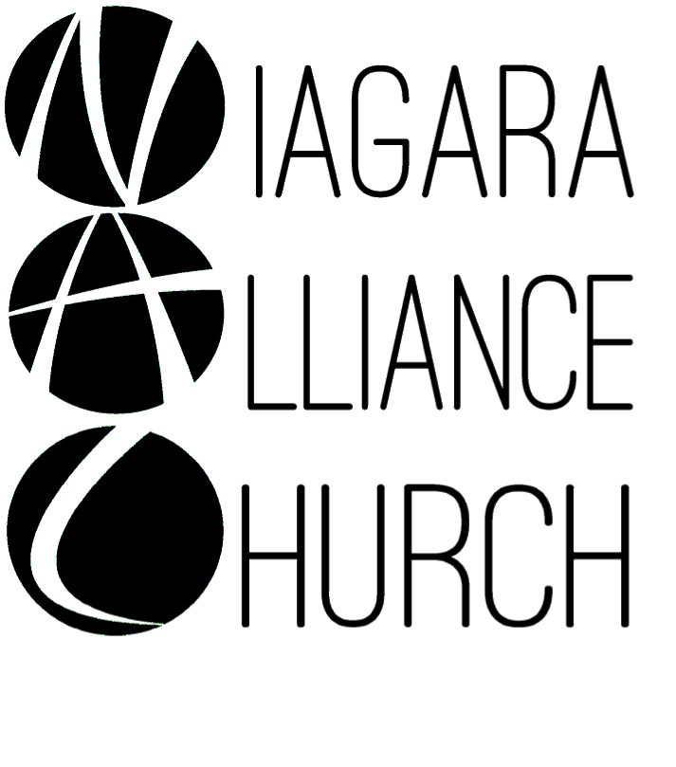
Weekly Worship at NAC:
Sundays:
9:30am LIFE Hour (Sunday School)
~ 9:15am for coffee
~ Classes offered for: adults, teens ages 12-18, middlers ages 8-11, juniors ages 3-7 and nursery services provided for birth-3 years old
~ Located in the library and downstairs fellowship hall
10:30am Worship Service
~ Nursery provided
~ Kids Connection (Children’s Church)- children ages 4-5th grade (age 11) are dismissed before the sermon begins for a biblical lesson and activities in the downstairs fellowship hall with two teachers
6-7:30pm: Breakout - Every Other Sunday Night:
Women’s Bible Study- located in the main foyer, Men’s Bible Study- located in the library,
Youth Group- 7th-12th grades (ages 12-18) - located in the downstairs teen room
Kingdom Kids (2 flexible age groups)- PreK-1st grade & 2nd -6th grades (about ages 3-7 and about ages 8-11) are invited for a hands-on Bible lesson and discussion, playing a game, and snack - located in the downstairs fellowship hall
Wednesdays: Prayer Meeting at 7pm- located in the front foyer and/or sanctuary

