Sunday, December 3rd, 2017

Welcome and thank you for joining us today.
As a guest or visitor, we acknowledge your presence as the only offering expected today.
Announcements

Christmas Program: The Christmas program will be held on December 10th at 6pm! Come join Bobby and her Emoji friends as they share the good news about the baby Jesus!
If you would be willing to bring a dozen cookies for our fellowship following the program, please sign up in the foyer.

Christmas Program: Children of all ages are encouraged to join us during Kid Connection to practice singing. See calendar insert for evening rehearsal dates.
Rehearsal TODAY right after morning service.

Sunday Evening Breakout: We would like to welcome you to join us every other Sunday evening from 6-7:30pm. Expect to enjoy fun, snacks, informal bible study and discussion on various topics. There are several options available to you: a Women's Bible Study led by Janice Bush, a Men’s Bible Study led by Bill Dudek, Youth Group led by Holly Piazza, & Kristine Pieczonka, Kingdom Kids ministry for children led by Stephanie Toohey & Pastor Dan, and Jean Brumfield will lead for ages 3-7. Come and grow in your faith by interacting with the body. Bring your children to do so as well. Today!

NGRM: Niagara Gospel Rescue Mission is a ministry devoted to feeding and witnessing to the homeless in Niagara Falls. If you would like to donate your time as a server or donate food/items, either would be greatly appreciated. The following items are needed: foam paper plates (dinner or salad size), spaghetti sauce, noodles, instant potatoes and canned vegetables. Please place donations in the wooden box located in the front foyer. Monetary donations or gift cards (Walmart, Wegmans, Tops, etc.) can be given through the offering, please label your envelope NGRM. If you have any questions or concerns, please see Val or Vikki Matuszkiewicz. Please continue to pray for this ministry.

Serving You
Today

Greeters: Pat Fox & Janet Emerson
Ushers: Team A
Nursery: Available (See Jean Brumfield)
Kids Connection: Holly & Abby Piazza

Next Sunday, December 10th, 2017
Greeters: Les & Debbie Spoth
Ushers: Team B
Nursery: Available (See Jean Brumfield)
Kids Connection: Jean Brumfield & Emily Shultz

Income/Expense Report for October
October Income | $9,668.51
October Expenses | $10,171.28
October Deficit | -$502.77

General Fund Balance | -$2,417.83
Loan Report for October
Original Loan Amount | $25,850.00
Minimum Payment | $249.61
Additional Payment on Principal | $100.oo

Remaining Loan Balance | $13,301.66

Chair Lift Project
Original Balance | $3,195.00
October Payments | $314.00

Remaining Balance | $2,881.00

December
Birthdays & Anniversaries
Dec 1 Kathy Franasiak
Dec 1 Nick Geschwender
Dec 4 Vikki Matuszkiewicz
Dec 6 Janice Bush
Dec 30 Jack & Janice Bush

For Your Assistance
In Touch Cards:
~ Submit a prayer request or request us to contact you
~ Located in the seat pockets
~ Place in the offering plate

Kids Connection (Children’s Church):
~ Held during the sermon
~ Age 4 -5th grade (age 11)
~ Please sign-in your children in the front foyer
~ Located in the attached building, down the stairs

Nursery:
~ Birth-age 3
~ Located in the attached building, up the stairs through the fellowship hall (in the former foyer next to the library)

Sermon Notes with Prize (for Children & Teens):
~ Fill out a note sheet located on the table in front of the sound booth
~ Turn in your sheet to Holly Piazza for a prize

Wireless Hearing Devices Available:
~ Ask at the sound booth for assistance

Easy Tithe (Online Giving):
~ Available at www.niagaraalliance.com

Charlie Severino Funeral & Memorial Service
Funeral – Sunday, December 3rd @ Saber Funeral Home, Viewings from 2-6pm, funeral to follow at 6.
Memorial Service – Saturday, December 9th at 2pm at Niagara Alliance Church.

Greetings

Thank you for joining us in worship today. We trust that God has crossed our paths for a reason. We do not believe your visit is by chance. We want to both encourage you and experience the blessing of your continued presence with us.

Jesus established the church to be a community — a family — to support each other and to tell the world about His love. As a church family, we endeavor to love each other without conditions. As humans we're not perfect at it, but nonetheless we seek to be used by the Lord to demonstrate His love to each other and to those around us.

If you are searching for a group of people who will accept you where you are at in your spiritual journey and also be used to help you grow in your relationship with the Lord, "Welcome" for that is our goal. We look forward to getting to know you better. We're glad you're here. Once again, welcome!

Who We Are

We are a church of the Christian and Missionary Alliance (C&MA), or “The Alliance” as we've come to call ourselves. We began as a missionary organization in 1887. Today there are over 2,000 C&MA churches in the US. We support over 800 missionaries who serve in 58 countries. There are also over 400 other missionaries supported by Alliance churches from at least 12 other countries. You can find out more about the Alliance at www.cmalliance.org

Our Vision

Niagara Alliance Church exists to be a Christ-centered community who gathers purposefully, fellowships personally, and worships passionately as Christ Jesus builds His Church through evangelism and discipleship.

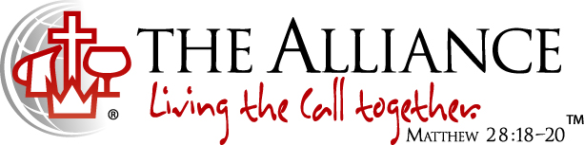
We believe in Jesus Christ as our Savior, Sanctifier, Healer and Coming King. This is expressed in the Alliance logo. The cross stands for the salvation made available to us through Jesus' death and resurrection. The cup was a vessel used by the Old Testament priests to wash their feet with before entering the Holy Place of the Temple and signifies the daily cleansing from sins by the power of the Holy Spirit. The pitcher speaks of oil, a symbol of divine life and physical healing that come from Jesus. The crown symbolizes the return of Jesus to the earth as King of kings and Lord of lords. The globe reminds us of our responsibility to take the message of Christ's love to the whole world. We live out this call together.

Contact Info
7041 Witmer Road
North Tonawanda, NY 14120
(716) 731-5689
www.niagaraalliance.com

Pastor Daniel Piazza
Office (716) 731-5689
danielpiazza@tfc.edu

Worship Leader- Dave Bishop
Cell (908) 989-0281
notesurfer@gmail.com

Church Office
Cell (716) 217-9262
Office (716) 731-5689
nacofficeniagara@gmail.com

Welcome To 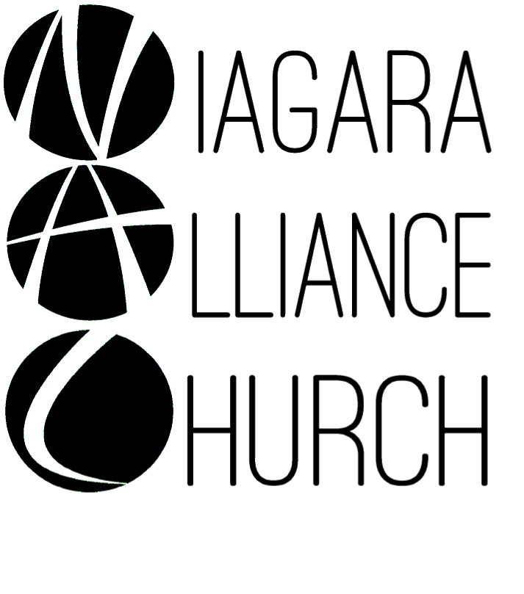
Weekly Worship at NAC:
Sundays:
9:30am LIFE Hour (Sunday School)
~ 9:15am for coffee
~ Classes offered for: adults, teens ages 12-18, middlers ages 8-11, juniors ages 3-7 and nursery services provided for birth-3 years old
~ Located in the library and downstairs fellowship hall
10:30am Worship Service
~ Nursery provided
~ Kids Connection (Children’s Church)- children ages 4-5th grade (age 11) are dismissed before the sermon begins for a biblical lesson and activities in the downstairs fellowship hall with two teachers
6-7:30pm Adult Services: Every Other Sunday
Women’s Bible Study
6-7:30pm Youth Services: Every Other Sunday
Kingdom Kids (2 age groups)- ages 3-7 and 8-11 are invited for a hands-on Bible lesson and discussion, playing a game, and snack
~ Located in the downstairs fellowship hall
Youth Group- ages 12-18 located in the downstairs teen room
Wednesdays:
Prayer Meeting at 7pm- located in the front foyer and/or sanctuary

