Sunday, January 28th, 2018

Welcome and thank you for joining us today.
As a guest or visitor, we acknowledge your presence as the only offering expected today.
Announcements

Sunday Evening Breakout: We would like to welcome you to join us every other Sunday evening from 6-7:30pm. Expect to enjoy fun, snacks, informal bible study and discussion on various topics. There are several options available to you: a Women's Bible Study led by Janice Bush, a Men’s Bible Study led by Bill Dudek, Youth Group led by Holly Piazza, & Kristine Pieczonka, Kingdom Kids ministry for children led by Stephanie Toohey & Pastor Dan, and Jean Brumfield will lead for ages 3-7. Come and grow in your faith by interacting with the body. Bring your children to do so as well. TONIGHT!

NGRM: Niagara Gospel Rescue Mission is a ministry devoted to feeding and witnessing to the homeless in Niagara Falls. If you would like to donate your time as a server or donate food/items, either would be greatly appreciated. The following items are needed: foam paper plates (dinner or salad size), spaghetti sauce, noodles, instant potatoes and canned vegetables. Please place donations in the wooden box located in the front foyer. Monetary donations or gift cards (Walmart, Wegmans, Tops, etc.) can be given through the offering, please label your envelope NGRM. If you have any questions or concerns, please see Val or Vikki Matuszkiewicz. Please continue to pray for this ministry.

Recycle for the Youth Ministry: Through our church's account with Bottle Junction we will receive $.06 for each piece of recycling rather than the normal $.05. You can participate in this fundraising opportunity by either dropping off your recycling in the foyer or by going to any of the Bottle Junction locations and dropping it off yourself. If you choose the latter option, just tell them to place it on the account for Niagara Alliance Church. Thanks, in advance for your generosity.
2018 Offering Envelopes: Offering envelopes for 2018 are available. If you wish to receive a set of envelopes please see Janice Bush. Thanks!

2017 Receipts: End of the year receipts have been given out. If you have any questions please contact Janice Bush.

Annual Meeting
The Annual Meeting will be held on February 11th following the morning worship service. We will have finger foods, snacks, and drinks. Please plan on atttending if you can! -Thank you

Directory Update
We are in the process of updating the NAC directory. We are asking each family/individual to fill out a directory update sheet and place it in the offering plate. We will also be taking directory photos throughout the month of February. Thank you so much for your help in updating this very useful church tool!

Serving You
Today

Greeters: Pat Fox & Janet Emerson
Ushers: Team C
Nursery: Available
Kids Connection: Stephenie Geschwender & Abby Piazza

Next Sunday, February 4th, 2018
Greeters:
Ushers: Team A
Nursery: Available
Kids Connection: Jean Brumfield & Emily Schultz

Income/Expense Report for December
December Income | $9,668.05
December Expenses | $8,981.97
December Surplus | $686.08

General Fund Balance | -$5,616.59
Loan Report for December
Original Loan Amount | $25,850.00
Minimum Payment | $249.61
Additional Payment on Principal | $125.oo

Remaining Loan Balance | $12,618.11
February
Birthdays and Anniversaries
Feb 2 Debbie Geschwender
Feb 13 Don Hall
Feb 14 Val Matuskiewcz
Feb 19 Stephenie Geschwender

For Your Assistance
In Touch Cards:
~ Submit a prayer request or request us to contact you
~ Located in the seat pockets
~ Place in the offering plate

Kids Connection (Children’s Church):
~ Held during the sermon
~ Age 4 -5th grade (age 11)
~ Please sign-in your children in the front foyer
~ Located in the attached building, down the stairs

Nursery:
~ Birth-age 3
~ Located in the attached building, up the stairs through the fellowship hall (in the former foyer next to the library)

Sermon Notes with Prize (for Children & Teens):
~ Fill out a note sheet located on the table in front of the sound booth
~ Turn in your sheet to Holly Piazza for a prize

Wireless Hearing Devices Available:
~ Ask at the sound booth for assistance

Easy Tithe (Online Giving):
~ Available at www.niagaraalliance.com

Greetings

Thank you for joining us in worship today. We trust that God has crossed our paths for a reason. We do not believe your visit is by chance. We want to both encourage you and experience the blessing of your continued presence with us.

Jesus established the church to be a community — a family — to support each other and to tell the world about His love. As a church family, we endeavor to love each other without conditions. As humans we're not perfect at it, but nonetheless we seek to be used by the Lord to demonstrate His love to each other and to those around us.

If you are searching for a group of people who will accept you where you are at in your spiritual journey and also be used to help you grow in your relationship with the Lord, "Welcome" for that is our goal. We look forward to getting to know you better. We're glad you're here. Once again, welcome!

Who We Are

We are a church of the Christian and Missionary Alliance (C&MA), or “The Alliance” as we've come to call ourselves. We began as a missionary organization in 1887. Today there are over 2,000 C&MA churches in the US. We support over 800 missionaries who serve in 58 countries. There are also over 400 other missionaries supported by Alliance churches from at least 12 other countries. You can find out more about the Alliance at www.cmalliance.org

Our Vision

Niagara Alliance Church exists to be a Christ-centered community who gathers purposefully, fellowships personally, and worships passionately as Christ Jesus builds His Church through evangelism and discipleship.

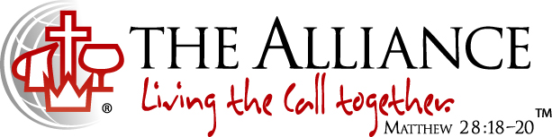
We believe in Jesus Christ as our Savior, Sanctifier, Healer and Coming King. This is expressed in the Alliance logo. The cross stands for the salvation made available to us through Jesus' death and resurrection. The cup was a vessel used by the Old Testament priests to wash their feet with before entering the Holy Place of the Temple and signifies the daily cleansing from sins by the power of the Holy Spirit. The pitcher speaks of oil, a symbol of divine life and physical healing that come from Jesus. The crown symbolizes the return of Jesus to the earth as King of kings and Lord of lords. The globe reminds us of our responsibility to take the message of Christ's love to the whole world. We live out this call together.

Contact Info
7041 Witmer Road
North Tonawanda, NY 14120
(716) 731-5689
www.niagaraalliance.com

Pastor- Rev. Daniel Piazza
Office (716) 731-5689
danielpiazza@tfc.edu

Worship Leader- Dave Bishop
Cell (908) 989-0281
notesurfer@gmail.com

Church Office
Cell (716) 217-9262
Office (716) 731-5689
nacofficeniagara@gmail.com

Welcome To 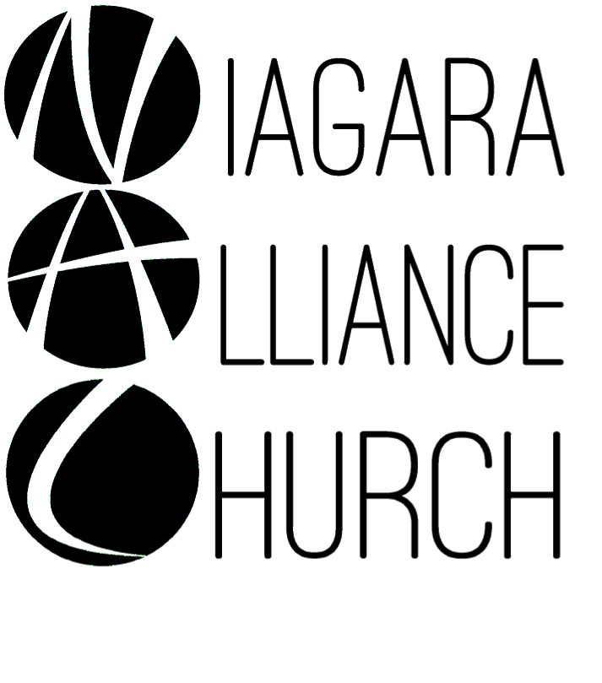
Weekly Worship at NAC:
Sundays:
9:30am LIFE Hour (Sunday School)
~ 9:15am for coffee
~ Classes offered for: adults, teens ages 12-18, middlers ages 8-11, juniors ages 3-7 and nursery services provided for birth-3 years old
~ Located in the library and downstairs fellowship hall
10:30am Worship Service
~ Nursery provided
~ Kids Connection (Children’s Church)- children ages 4-5th grade (age 11) are dismissed before the sermon begins for a biblical lesson and activities in the downstairs fellowship hall with two teachers
6-7:30pm Adult Services: Every Other Sunday
Women’s Bible Study
6-7:30pm Youth Services: Every Other Sunday
Kingdom Kids (2 age groups)- ages 3-7 and 8-11 are invited for a hands-on Bible lesson and discussion, playing a game, and snack
~ Located in the downstairs fellowship hall
Youth Group- ages 12-18 located in the downstairs teen room
Wednesdays:
Prayer Meeting at 7pm- located in the front foyer and/or sanctuary

